2026 ONLINE PLEDGE CARD INSTRUCTIONS

State employees who have access to the Employees Self-Service Portal (ESS) may choose to complete their MSECC pledge card online.

REGISTERING FOR ESS

For employees who do not have an active ESS account, signing up is easy. Visit https://ess.mo.gov/ and click the “Register Now” button under the “Registration” heading. Active state employees must fill out their last name, last four digits of their SSN, date of birth, agency where they work, ZIP Code of residence, and the net pay on their most recent paycheck.

EMPLOYEES ALREADY REGISTERED FOR ESS

If you already have an account with ESS, once you have logged in, the MSECC Pledge Card is located in the “My Information” dropdown menu in the upper right-hand corner.

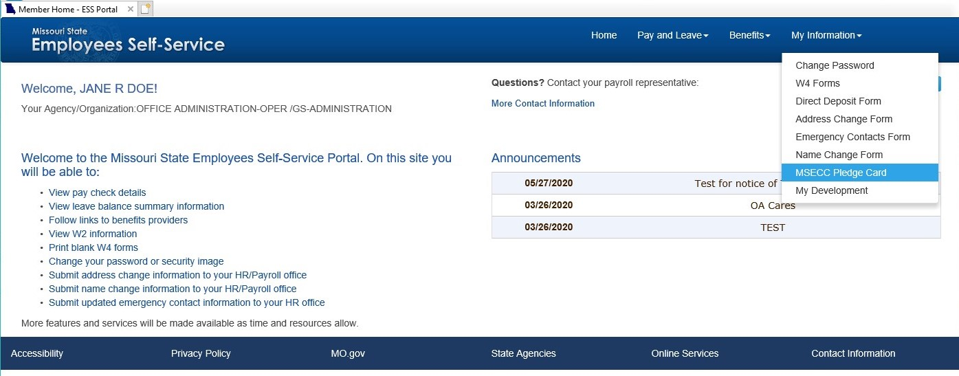

After selecting “MSECC Pledge Card”, you will be directed to the online donation platform. 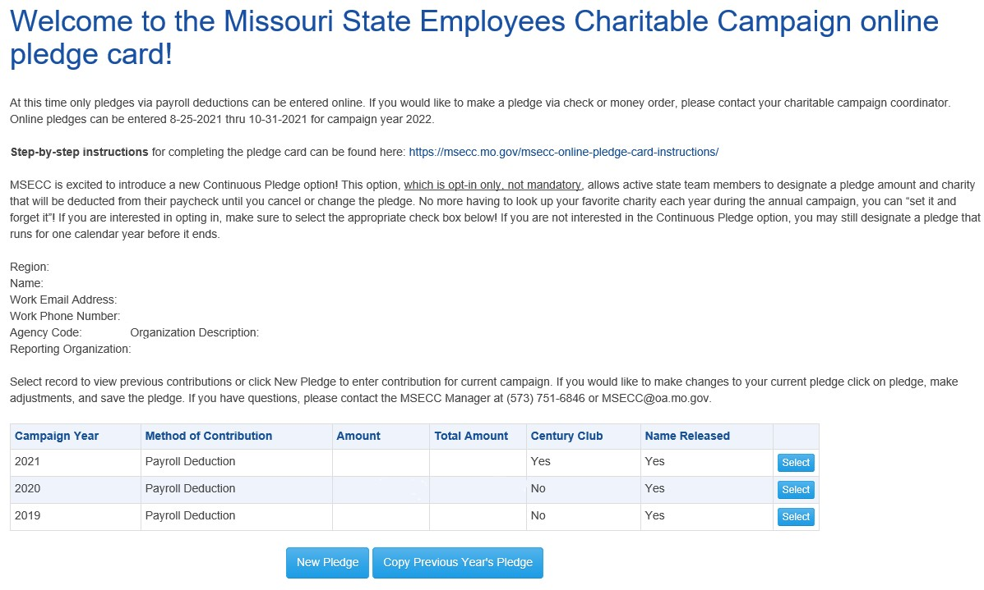
The online pledge card has a record of your previous donations to the campaign.
To complete a new pledge, click the “New Pledge” button. Or, you may copy your previous year’s pledge.

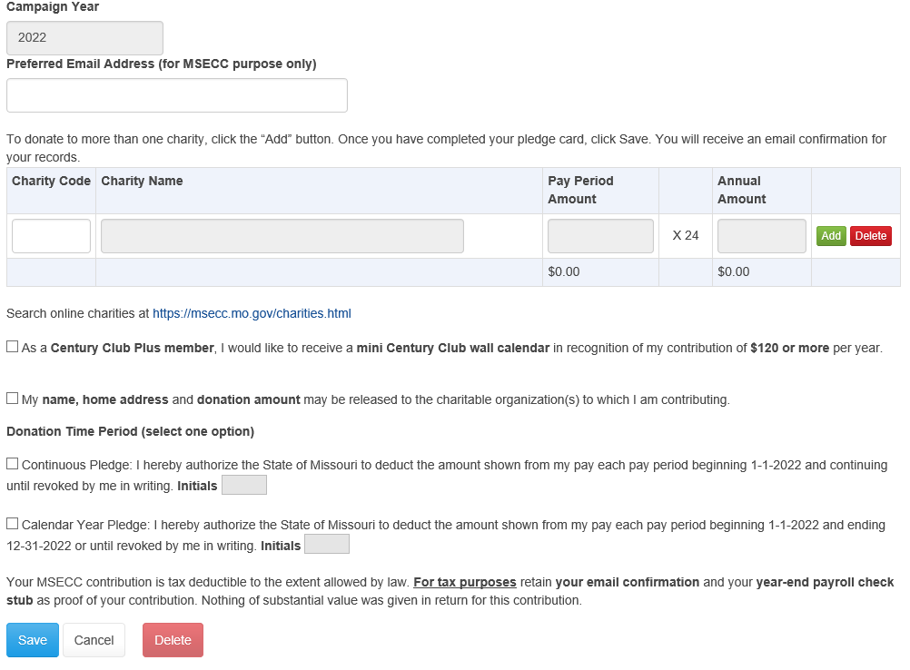

Employees will fill in: a preferred e-mail address (if other than work e-mail), charity code(s) and contribution amounts. Charity codes may be obtained from the “Quick Charity Reference Guide” or the MSECC website: https://msecc.mo.gov/public/charities.html. Employees may choose to be recognized for contributing $120 or more annually (Century Club Plus). They can authorize the release of their name, home address, and donation amount to their recipient charity by checking the appropriate boxes on the pledge card. Employees must also specify the time period for their pledge, either for one calendar year or a continuous pledge that will roll over annually. The pledge card must be initialed (in place of a signature). To donate to more than one charity, click “Add” to add another line. You may donate to as many charities as you wish.

Once you have completed your pledge card, click the “Save” button. A window will appear to confirm whether you’re sure you want to save. Selecting “OK” will submit your pledge.
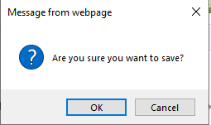

You will see a green bar indicating that your pledge was submitted successfully.
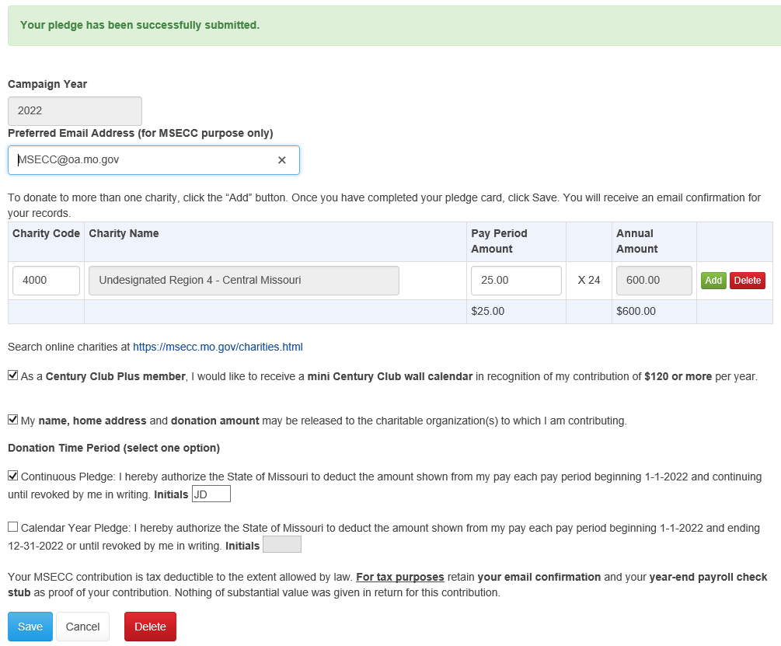

At any point in the campaign, you have the option to delete your existing pledge and enter a different one. Once the campaign closes, if you’d like to make changes to your pledge, contact the MSECC Manager at msecc@oa.mo.gov or 573-751-5076.

You will receive a confirmation email to your work email or preferred email address as entered above for MSECC purposes only.

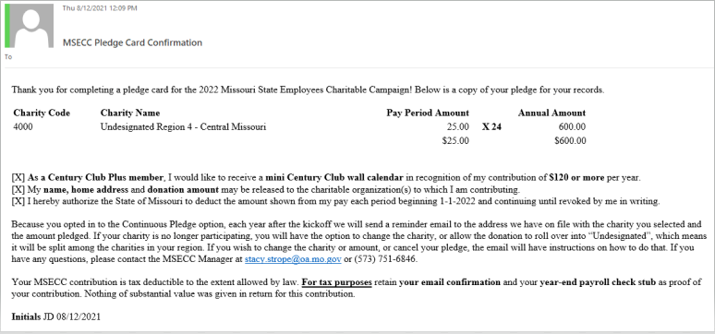

Pledge cards may be submitted via the online platform between the statewide kickoff date, August 27, 2025, and the campaign end date, October 31, 2025.

If you wish to make a change to your previously submitted pledge card or need further assistance, please contact the statewide MSECC Manager at 573-751-5076 or MSECC@oa.mo.gov.

Revised 07/07/2025



