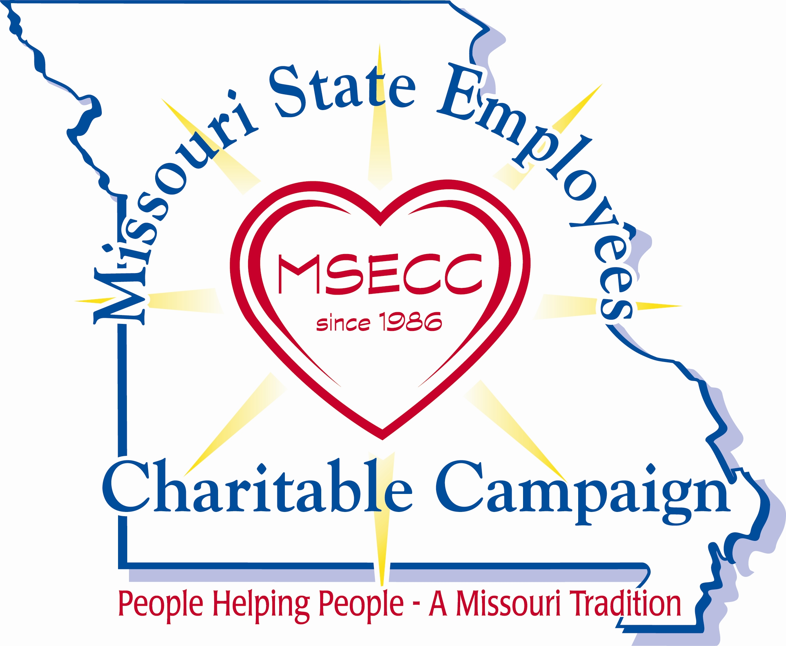
CAMPAIGN COORDINATOR CHECKLIST

- The statewide “Kick-Off” date is Wednesday, August 28, 2024. The campaign period will run August 28 through October 31, 2024.

- The theme for the 2024 campaign is “Light the Flame of Hope“



ENLIST SOME HELP…
- Enlist the support of your department director relating to campaign activities.
- Select enthusiastic volunteers to assist you. For agencies with outlying offices, select site coordinators to help you facilitate campaign activities, distribute materials, collect pledge cards, and promote the online donation platform and credit card donation option.

GET STARTED…
- Campaign materials (posters, pledge cards, batch reports/envelopes and incentive items) will be shipped to department coordinators in August.
- Department coordinators - Prepare materials for site distribution delivery no later than August 30.

SET YOUR CAMPAIGN GOAL…
- Review your department’s giving history – e-mail the campaign office for a copy.
- Set a goal – Establishing a target serves as a motivator to achieve better results. Your campaign goal should be realistic yet challenging! Set a goal for both dollars raised and percent participation.
- Talk with last year’s campaign coordinator from your department. Find out what worked and what didn’t work for them.
- For assistance with planning and goal setting you can also contact the Statewide Campaign Manager’s office at 573-751-6846 or e-mail questions to msecc@oa.mo.gov.
PLAN YOUR KICK-OFF EVENT…
- Determine your agency’s campaign timeframe within the above dates. For agencies using paper pledge cards, distribute them to employees no later than October 15.
- To maximize interest, plan to conduct your campaign in a two-week timeframe. Short campaigns keep the momentum and enthusiasm high and have proven to be the most effective. Employees can still turn in their pledge cards after your campaign “officially” ends.
- Promote your campaign – Use employee newsletters, e-mail, and campaign posters to build awareness about the upcoming campaign.
- Hold a kickoff event - invite a participating MSECC charity to speak OR invite a fellow employee who may have benefited from a participating charity to share with co-workers how they were helped.
- Increase employee awareness by holding a special fundraiser - Plan and conduct a fun activity (see fundraising ideas) that will encourage participation and motivate employees to give.
- Use incentive items provided by the campaign office for employees who return their pledge card or use the new online donation platform.

DURING YOUR CAMPAIGN…
- Instruct site coordinators on how they should track employee contributions and if they should return pledge cards (if applicable) to you OR send them directly to the MSECC office.
- Monitor which outlying offices you have received batches from and follow up with those that have not responded.
- Keep collected pledge cards in a safe and secure location until they are sent to the MSECC office.
- Ensure each employee has access to the online donation platform on ESS, a paper pledge card, or the credit card donation option.
- To select a charity, they can review the campaign charity guide or refer them to the website https://www.msecc.mo.gov to select their charities.

REMEMBER TO…
- Point out the advantages of payroll deduction – emphasize that no gift is too small - even if it is only .50 per pay period - every dollar makes a difference!
- Follow-up with employees whether or not they chose to make a donation. Please remember that participation is voluntary, and no one should be pressured to donate.
- Include all employees who return pledge cards in your drawings for incentive items.

WRAP UP and THANK YOU…
- Always accept employees pledge cards, even after your campaign “officially” ends.
- Extend your personal thanks to the donors and other volunteers who assist you.
- Make sure your employees know the results of the campaign for the work site, department, and statewide.

Revised 08/26/2024

