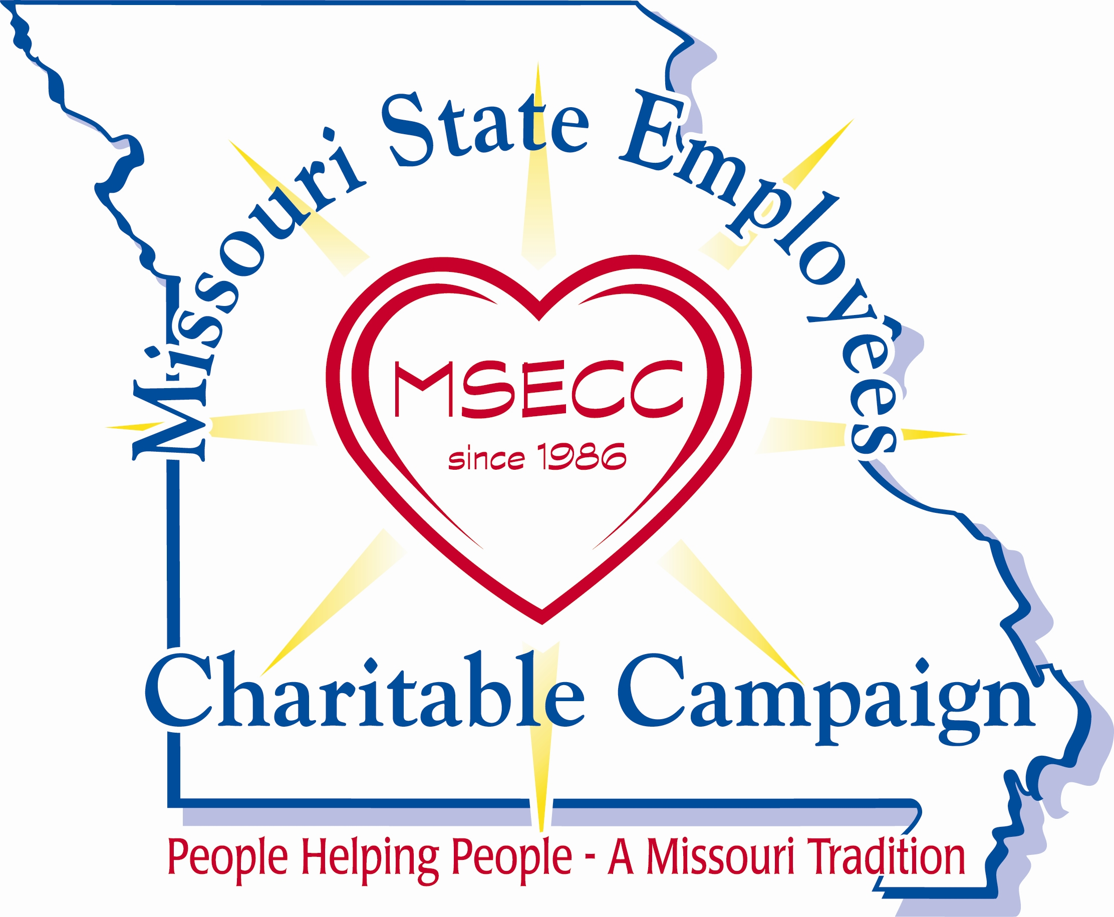

Planning Special Events…

You will be amazed at the difference that holding special fundraiser events can make for your campaign. Not only will you raise more money, but you will also keep employee interest high – and it’s fun! Fundraisers raised more than $39,000.00 during the 2023 campaign.

At your Kick-Off – invite a charity to speak OR invite a fellow employee who may have benefited from a participating MSECC charity to share with other employees how they were helped.

Balloon Theme: With the “Helping Others Rise Above” theme, have fun! Use a hot air balloon to track department goals, invite someone to make balloon animals at your kick-off, etc.

Root Beer Float sale: Make and sell root beer floats during your afternoon break.

Ask management to donate a parking space for a week/month and auction it to the highest bidder, or use it as a prize.

Jean day passes: This is always a popular fundraiser!

Silent Auction: Have employees/managers donate new or gently used items.
Fellow employees can purchase the items.

Guess how many water balloons in the jar!

Book/Movie Fair: Have employees donate used books and movies for coworkers to purchase.

Ice cream socials – Set up an ice cream bar with a variety of favorite toppings. Charge a “Buck-a Bowl”. Everyone loves ice cream!!

Bake Sale: Enlist some office bakers to make special treats, cakes, cookies or pies to sell. Individually wrapped smaller portions seem to be the most popular!

Balloon-o-gram: Sell balloons to employees with special messages or candy attached to give to their coworkers. Employees get “something sweet” and your office gets decorated with colorful balloons!

Baby Photo Contest: Wow, who would have thought your boss was such a cute baby? Ask your co-workers to bring in their baby photos, scan the photos and create a sheet to be circulated.

Cupcake Wars: Have employees bake cupcakes and co-workers vote on their favorite. Sell the cupcakes!

Pumpkin Decorating Contest: Place pumpkins on display along with a donation jar for employees to put money in for their favorites. The decorator of the pumpkin with the most money at the end of the week will win and gets to choose the participating MSECC charity to receive the donations.

Be a Lifesaver: Have some fun – beach style! Sand, sunglasses, beach balls and The Beach Boys music make your office feel like you are on the beach. Have a sand bucket for employees to place their pledge card in at the event and do a drawing for prizes (lifesaver candies, water wings, swim rings, swim goggles, beach towel, sunglasses).

Balloon Pop Use the MSECC incentive items that you received, casual day pass or donated parking space. Before filling balloons, put a note inside some of the balloons with the name of the prize. In other balloons, put a note “thank you for giving from the heart”. If an employee turns in their pledge card by a specific date – they get a balloon to pop.

BE CREATIVE…There are a million FUN things you can do for special events!!! Don’t be afraid to have some fun! A fresh and fun campaign makes your job more enjoyable and creates awareness and BUZZ among your co-workers!

Revised 07/25/2023

